Relaxing Rice
This past weekend I was inspired to dye rice using Kool-aid. My intentions were to make a rice tray; a colorful alternative to a sand tray. I also thought... maybe students could make feelings jars. Let each color represent a feeling and have students make a visual of how much of each feeling they have in a sealed jar. It would make a beautiful piece of art out of an issue that is on the mind of the students.
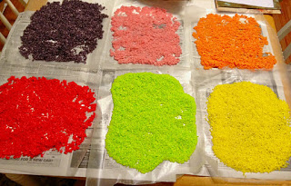

The process was so simple! Put about 1 cup of rice in a ziplock bag. Use 2 tablespoons of hot water to liquify the Kool-aid powder. Pour into the ziplock bag of rice. Squish, squash, mash and the rice is covered in color. Pour the rice out on wax paper and spread out to dry. It only took about 15 minutes to dry, but I left it out for longer just to make sure. I made bags of different colors of rice - cherry red, grape purple, watermelon pink, orangy orange. Plus I used food coloring to make some yellow, green, and blue.

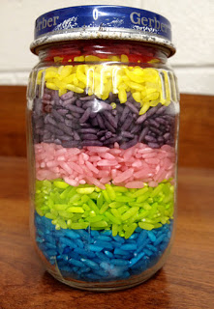
I couldn't wait to take it to school and find a use for my dyed rice. The first opportunity presented itself very quickly. As I was working with a student on how to relax and manage her anger in a better way, we were trying to come up with alternatives to destroying classroom property. The student spotted my dyed rice that I had sitting on my counter and wanted to know how I had made the colored rice. As we were talking and still discussing ways to cool down, it occurred to me that instead of counting to 10, I can give her something to get her mind off of the situation long enough to calm down. We then made a Relax Jar. Using beads with the letters R-E-L-A-X and other small beads and sequins, we filled a baby jar with blue rice. We left a little air at the top so she can rotate the jar and the rice will slide around inside revealing the letter beads and sequins. Now when she gets angry, she can turn the jar until she finds all the letters that spell relax. Hopefully she will have had enough time to calm down!
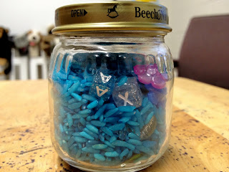
I am sure I will be coming up with more ways to use my rainbow rice while counseling students. Any thoughts?
UPDATE JULY 2014:
I still love this rice. I have been using it with students for a year and a half now. If you keep the rice in an air tight container, it lasts forever! I love to reuse my liquid coffee-mate containers. Just peel off the wrapper and you have a clear container filled with colored rice and a convenient pouring spout!
I just made another 14 pounds for the next school year. Some things I have discovered:
- Use 1 pack of Kool Aid per pound of rice
- The flavors I used are mixed berry (blue), strawberry kiwi (pink), green apple (green), lemonade with a few drops of yellow food coloring (yellow), grape (purple), orange (orange, obviously), black cherry (red).
- Only add a few spoonfuls of water to mix the powder
- Put rice and Kool Aid dye in a quart size ziplock and Shake, Shake, Shake. It only takes about 30 seconds.

